Created by
Crystal Gilbert

Edited by
Sherron Burns

Living Sky
School Division No. 202
Grade 9
Arts Education

Visual Arts

Outcome
CP9.12
CR9.3
9
Problem Solving Portraits:
Caricatures Thinking Outside the Box

Essential Question:
How is identity reflected through caricature?

Artists take risks and problem solve in many ways.

Understanding the elements of art broadens my approach to creating art.

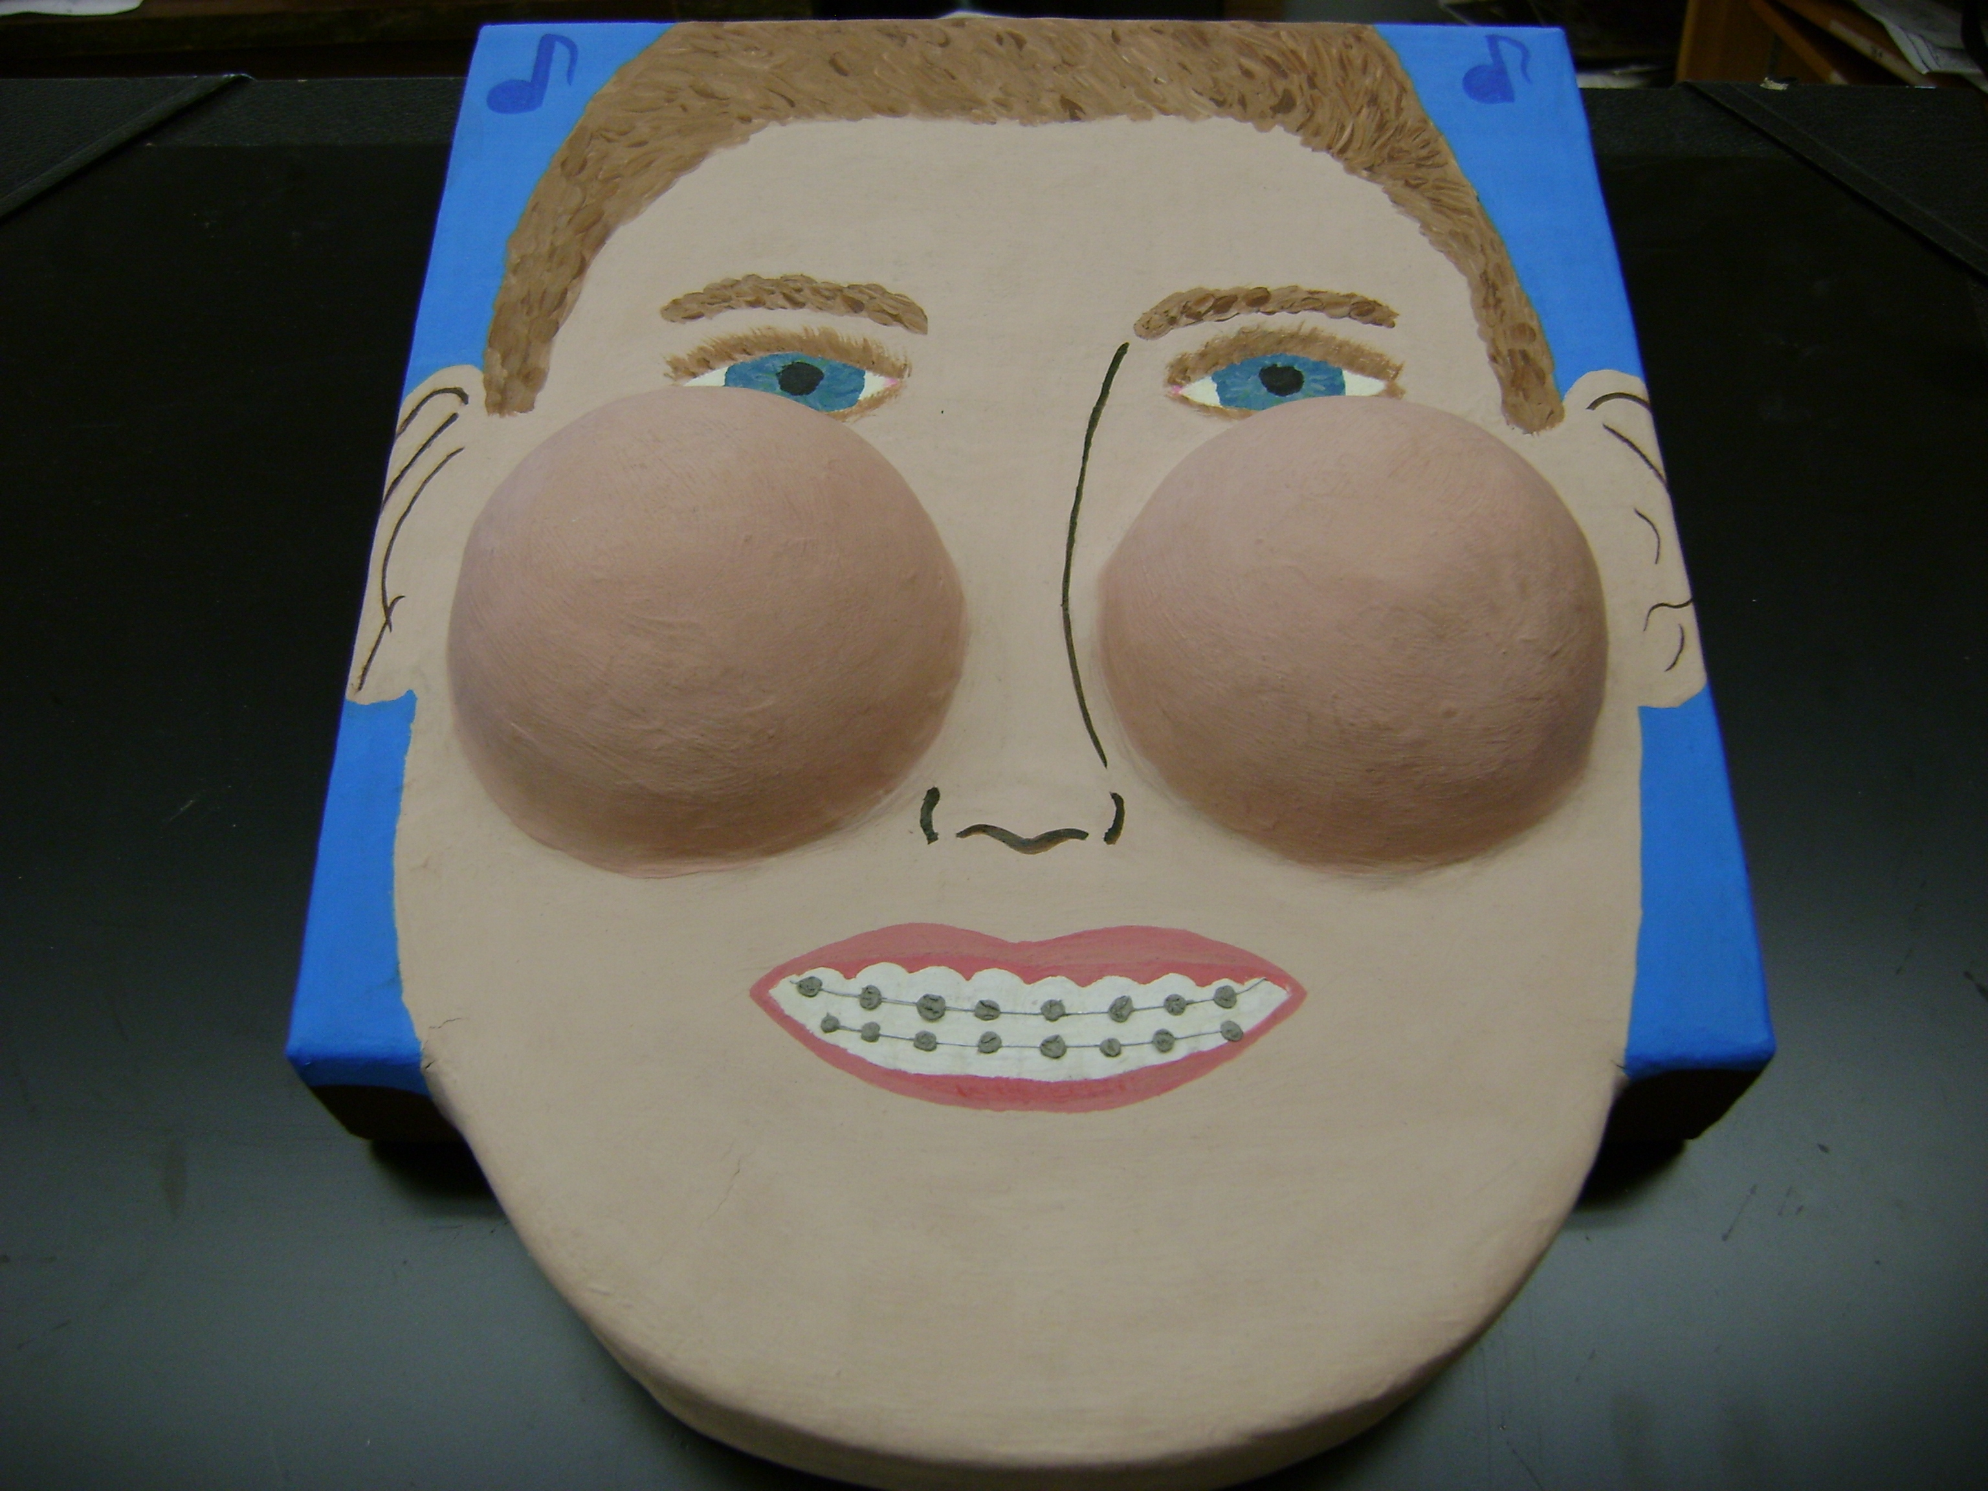

Materials/ media impact choices in an artwork.

Portraits can reveal personality and character.

Students will examine identity and ways to solve problems of portrayal through caricature. Discussions about the ‘beauty myth’, self-concept and risk taking will be explored as students examine the work of artists and create their personal self portrait.
Grade 9

Visual Arts

Outcomes
CP9.12

Living Sky School Division no. 202
I. Curriculum
Outcome: Creative Productive

CP9.12 Solve visual art problems in new and unfamiliar ways.
- Take risks by working in unfamiliar ways (e.g. new ideas, techniques, or media)
- Experiment with new ways of using symbols and manipulation of images.
- Solve problems in innovative ways.
- Describe own decision making and problem-solving processes and reflect on choices made.

Outcome: Critical Responsive

CR9.3 Investigate and identify how arts expressions can challenge thinking about values, ideas and beliefs.
- Describe how the arts can transmit or question values, ideas and beliefs.
- Examine the intentions, development and interpretations of own arts expressions in relation to own experience, values and perspectives.
- Investigate and explain why some arts expressions were considered to be controversial at different times in history.

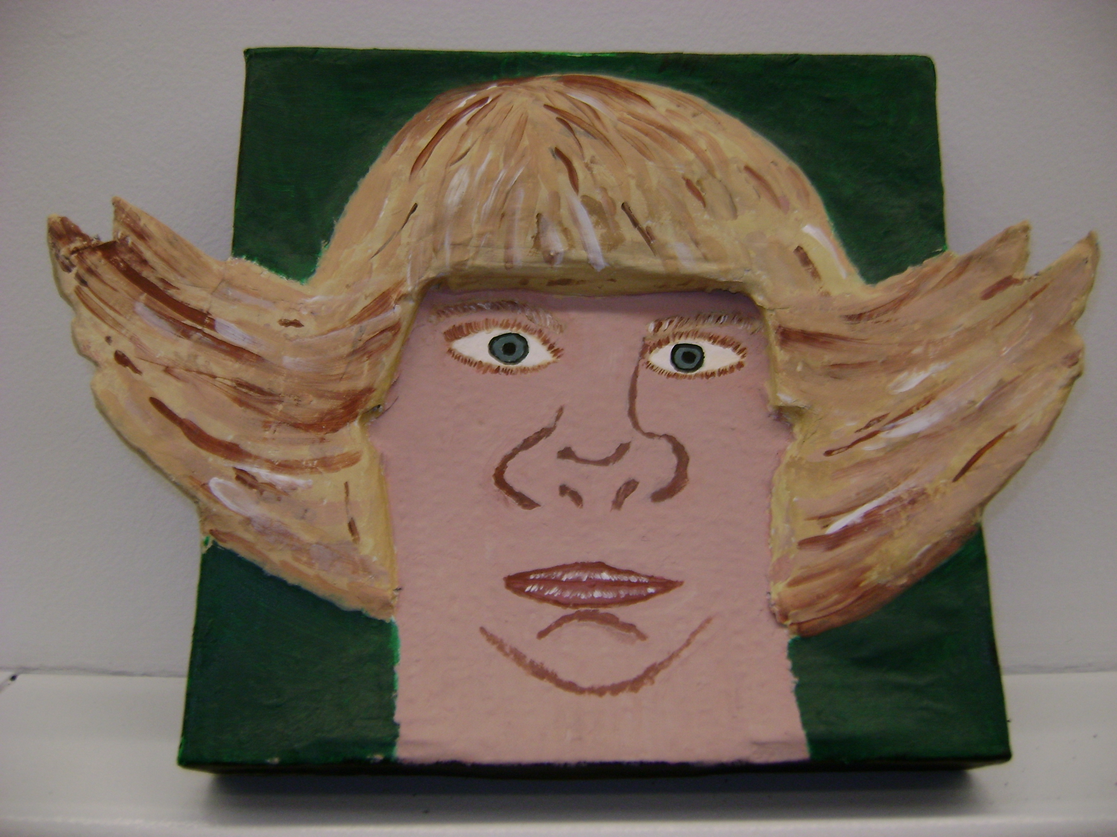
Student example shows exaggeration of features and working outside the frame.
II. Overview

Students will know:
- Qualities that constitute caricature, and how it differs from cartoon and portraiture.
- There is a language and vocabulary specific to caricature.
- Artists solve problems in unique ways.
- Artists have careers as caricature artists - political satire & entertainment.
- Understand the methods artists use to exaggerate features.
- Sculpture requires attention to surface details and materials used.
- Paint can be applied intentionally for effect.
Students will do:
- Research examples of artist’s work, collect a Visual Library and discuss various styles and approaches.
- Personal survey on attitudes regarding beauty.
- Analyze photos of themselves, choose features to exaggerate and draw the caricature.
- Prepare the surface, apply papier mache to create a modeled 3D effect, incorporate the caricature drawing – solve problems as they arise.
- Paint technique, brush style.
- Peer critical viewing and discussion.

Questions for Deeper Understanding

How can I represent myself in new and different ways? What will this say about me?
How is self concept & identity affected by perceptions of beauty and societal expectations? How do others see me – and how do I see myself?
What makes me willing to take risks?
How have other artists solved this problem?
What is the role of parody and satire in caricature?
How will the media/material impact the choices to be made?
III. Assessment Plan
Formative
Assessment Evidence | Assessment Task
- Frayer Model  - Survey of class | - Identify examples, definitions, images and non-examples of caricature.  - Pre-assess attitudes re: beauty  and attitudes re: risk taking
- Observations: Plan for portrait, practice drawings, descriptions, discussion | - Anatomy & proportion pre/post drawings  - photo of self, analysis  - personal symbols, colour
- Journal & Visual library of portraits | - Reflection and plan  - Collect examples of artist self portraits, media images, caricatures
- Discussions  - Observations | - Decisions, problem solving  - Awareness of process
- Teacher conferencing  - Peer critique | - Sharing process, problem solving and innovations

Summative

Assessment Evidence | Assessment Task
- Process folio: select three items that best illustrate your choices, experimentation and risk taking | - Assemble your drawings, designs, questions, symbols, problems and risks to illustrate your process
- Co-construct criteria for rubric | - Discuss criteria for product as a class

IV. Learning Plan

Lesson One: “What Is Caricature?”
Time Frame: 2 hours

- Surveying Attitudes and Beliefs: Ask students about their ideas and attitudes regarding beauty and self-confidence. What do they need in the classroom to feel safe enough to take risks in their art making? Students define caricature and discuss the main differences between caricature, cartooning, and portraiture.
- Creating Context: Students create a visual library of caricatures from both local and international artists from various eras of history. Students research origins of caricature, artists, and techniques. A caricature is the satirical illustration of a person or a thing, but a cartoon is the satirical illustration of an idea. Define “caricature” and discuss parody, satire, political caricatures and the beauty myth. There are various videos related to pop culture, beauty and expectations for both men and women. From Da Vinci to Rolling Stone magazine, caricature artists help us see individuals in new light.
- Frayer Model: Develop a Frayer Model to illustrate the definition of terms, related images and key artists, examples and non-examples of caricature. Show understanding of the concepts by comparing examples from other artists. This approach to learning a new concept scaffolds learning as they build upon the term or definition to show their understanding through examples. Students can continue to add to their Frayer Model as new information is learned and can be used as a quick reference sheet. (see appendix)
Optional technology: iPods and iPads have cartoon apps that will help provide an image for their self portrait.
- Discuss Ideas: Why do artists exaggerate certain features and what might be exaggerated in your own work? Students work from traditional school photos taken in a neutral pose, ie: eye level perspective, head shot, or they might choose to take new pictures in interesting settings or from unusual angles. Consider images or symbols that represent personal interests both inside and outside of school, (for example, poetry or song lyrics, musical instruments, or sports).

Lesson two: “Getting Started”
Time Frame: 1.5 – 2 hours

- Anatomy & Proportion: Before and after drawings – students are asked to draw a face of an imagined person. Learn/review standard placement of facial features and spheres of the head. Provide several non-examples of correct proportion and placement to identify common problems. Discuss “learning to see” and drawing what we see rather than what we think we see. Students are asked to draw another face and to compare the differences between the first and second examples. Discuss this with a partner.
- Practice Seeing: Teacher and student volunteers are used to identify differences in faces. Be sure to approach this in a very positive manner, to celebrate, embrace, and recognize our individualism. Humour is powerful and we can poke fun at ourselves through art. This exercise can help create a positive climate and a safe sense of community and led students to exaggerate individual differences to create humour in their drawings.
Many resources to choose from, one is: “Guidelines for Face Portraits and Proportions”, wikihow.com/Draw-Human-Faces.

- Practice Drawing: Use overhead transparencies and washable markers to trace and alter photos. Use student feedback and peer conferencing to determine if there is a balance between likeness and the exaggerated features intended to create humour.

- Reflect: Use a visual journal to document feelings about the exercise and determine what type of exaggerations to make. Did the student feel confident that he/she could take a risk and exaggerate something distinct about themselves?
Teach use of specific vocabulary for giving constructive feedback.
- Big Ideas: Discuss the big ideas and essential questions. How are artists able to problem solve and create with innovative ideas?
- Co-construct Criteria: as a class brainstorm the criteria that should be evident in the product to reflect history, ideas, problem solving, risk taking, and technique. Post the criteria. Post challenges to one another for consideration in the process to keep the ideas fresh and innovative.

Lesson Three: “The Sculpture”
Time frame: up to 10 hours

- Materials: surface on which to build the caricature (i.e.: large pizza boxes), flour/paste/glue, spoons, newspaper, containers with lids, gesso or primer, sand paper, paint.
- Preparation: paint gesso (house primer will work) on each box and let dry.
- Technique: Use the drawing from the transparency to transfer the image to the box. Trace the transparency on top of the gesso prepared box, or draw free-hand using a mirror. The drawing will become 3 dimensional with papier mache and other found materials.

Colour choices and symbols act as a way of informing the viewer about the artist and of his or her interests.
Papier mache: Mix water and flour, wallpaper paste or glue and water – to the consistency of a cream soup. It should not have lumps or be too watered down. Mache areas to be at least 2 inches thick so they can also sand the surface.
Preparation to Paint: apply 2 coats of gesso.
Students work in groups and problem solve as needed.

Draw the image again and add in the body, consider physical stance, attire and props that represent the character. Add background colour and symbols.

- Review design concepts using the principles and elements of design through class discussion.
- Peer Critique work with a partner to discuss ideas and execution of your idea.
- Problem Solving is encouraged through ongoing discussions and sharing of work.
- Observations & conversations: use formative assessment throughout to check for humour and proper technique in painting.
- New Media, New Problem: Students invited to incorporate mixed media in their self portrait.

Lesson Four: “Gallery Walk”
Time frame: 1 hour

- Gallery Walk: Create a student gallery, a “hall of fame” in the school. Ask students from other classes to identify the caricature to the correct person. How could they tell whom it was representing?

- Caption contest: Create funny captions for each other on post it notes. Maybe caricatures next to one another will have a dialogue.

- Self Assess: Review the criteria constructed as a group and self assess the self portrait.

- Teacher conference: Discuss the process of discovery, problem solving and risk taking as evidenced in the product.

V. Appendix

Student examples page 10 & 11

Resources page 12 & 13

Frayer Model page 14

Peer Critique page 15

Project Rubric page 16 & 17

Student Examples

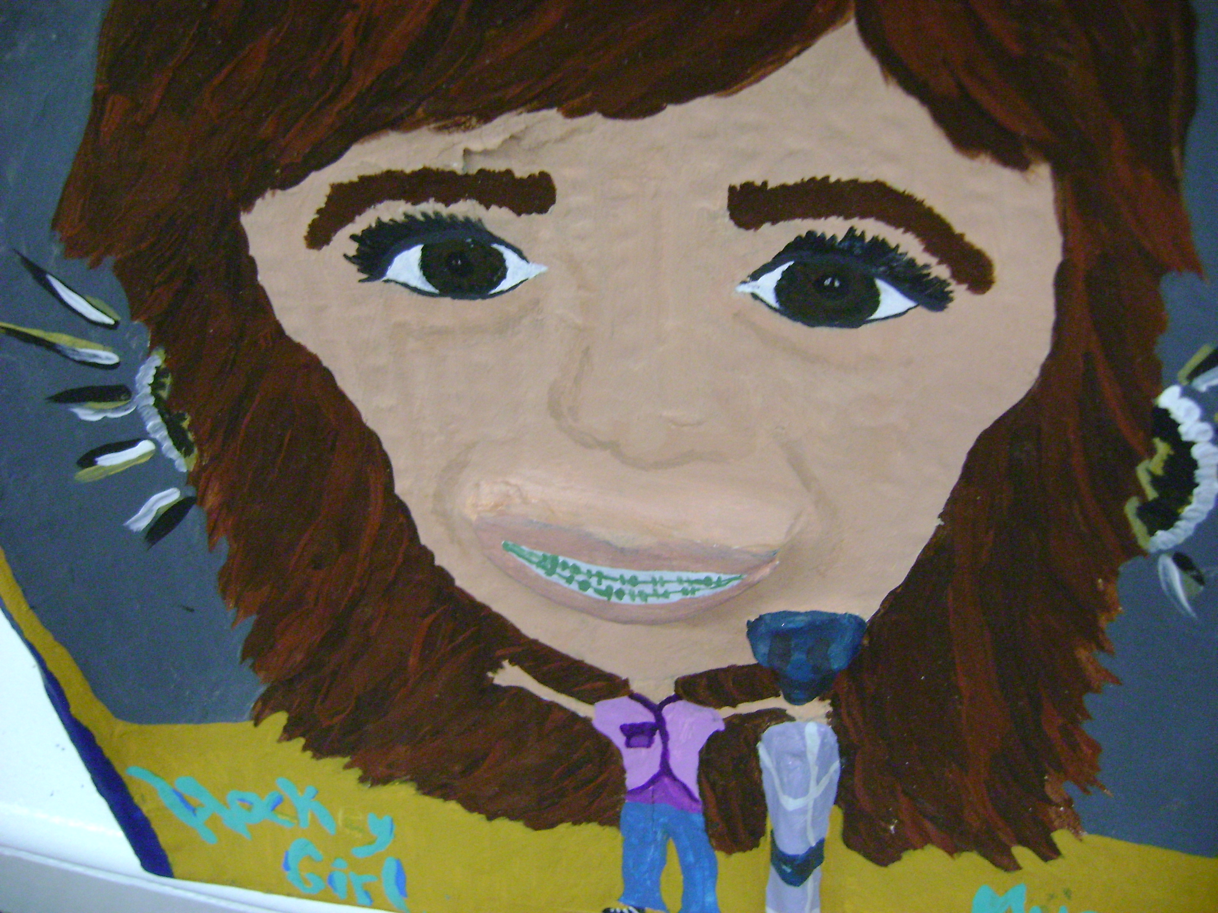

Risk Taking: 3D focus on the mouth, braces and microphone. Selection of symbols effective for personal interpretation.

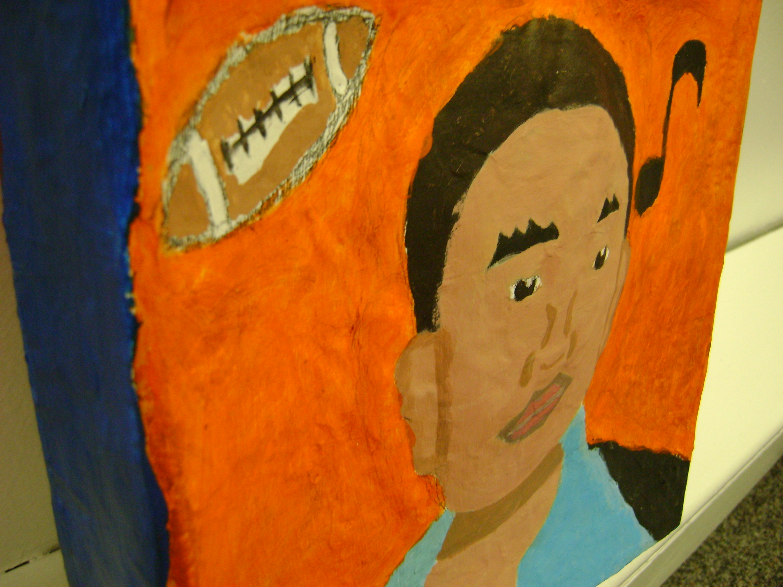

Not much exaggeration of features, but clear use of symbols. 3D construction was not very evident.

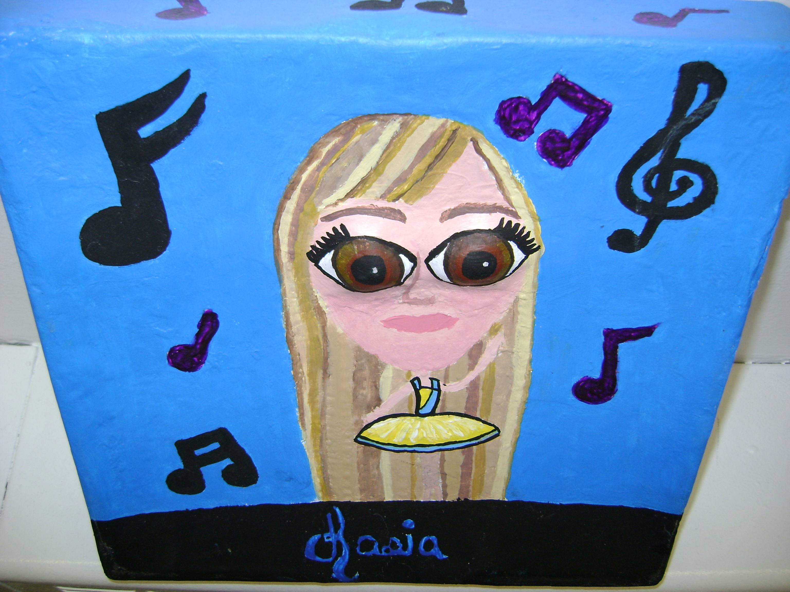
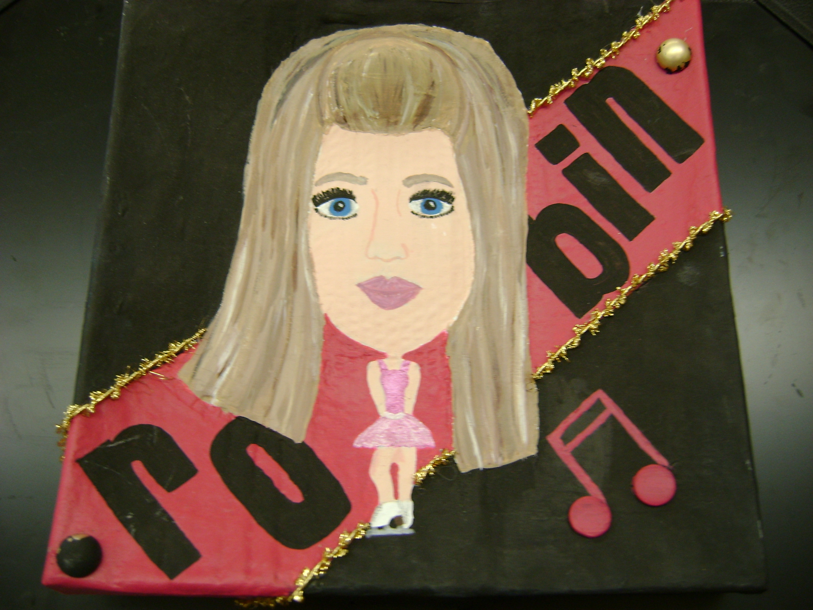
Student identified feeling self-conscious about taking risks and did not exaggerate features. Solved problems in a variety of ways and used a variety of material to create an effect.
Hugely exaggerated eyes bulged from the 3D construction. Colour choice appropriate, good use of technique and material.
Resources

http://www.wikihow.com/Draw-Human-Faces
This site helps students learn how to draw the features in proportion and in proper relationship to one another.
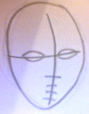

Caricature books and websites:

The Savage Mirror, The Art of Contemporary Caricature, by Steven and Gail Anderson.

L’Art de la Caricature, A la Portee de Tous, by Jan Opdebeeck

Pens and Needles, Literary Caricatures by David Levine, Introduced and Selected by John Updike

The Art of Jack Davis, by Hank Harrison

The Complete Book of Caricature, by Bob Staake

Stars, by Sebastian Kruger

How to Draw Caricatures, by Lenn Redman

Caricatures (Learn to Draw), by Alex Hughes
Hirschfeld’s Hollywood, The Film Art of Al Hirschfeld, by David Leopold

Let's Toon CARICATURES, by Keelan Parham

Party of 1, Roadkill of an Itinerant Caricaturist, by Sam Klemke

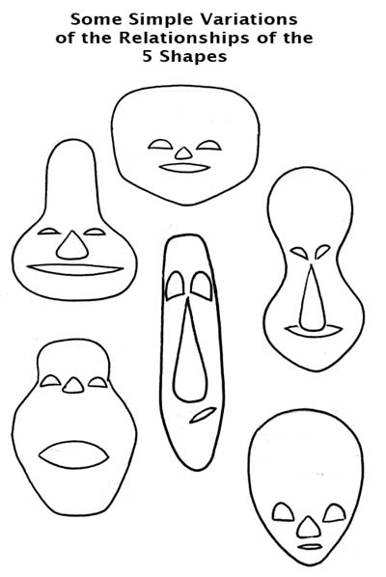

The Mad Blog – How to Draw Caricatures

http://www.tomrichmond.com/blog/2008/02/14/how-to-draw-caricatures-1-the-5-shapes/

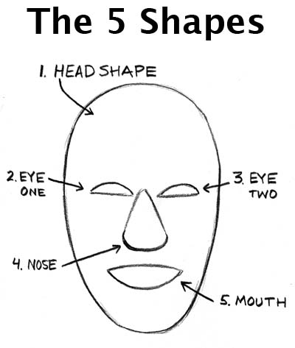

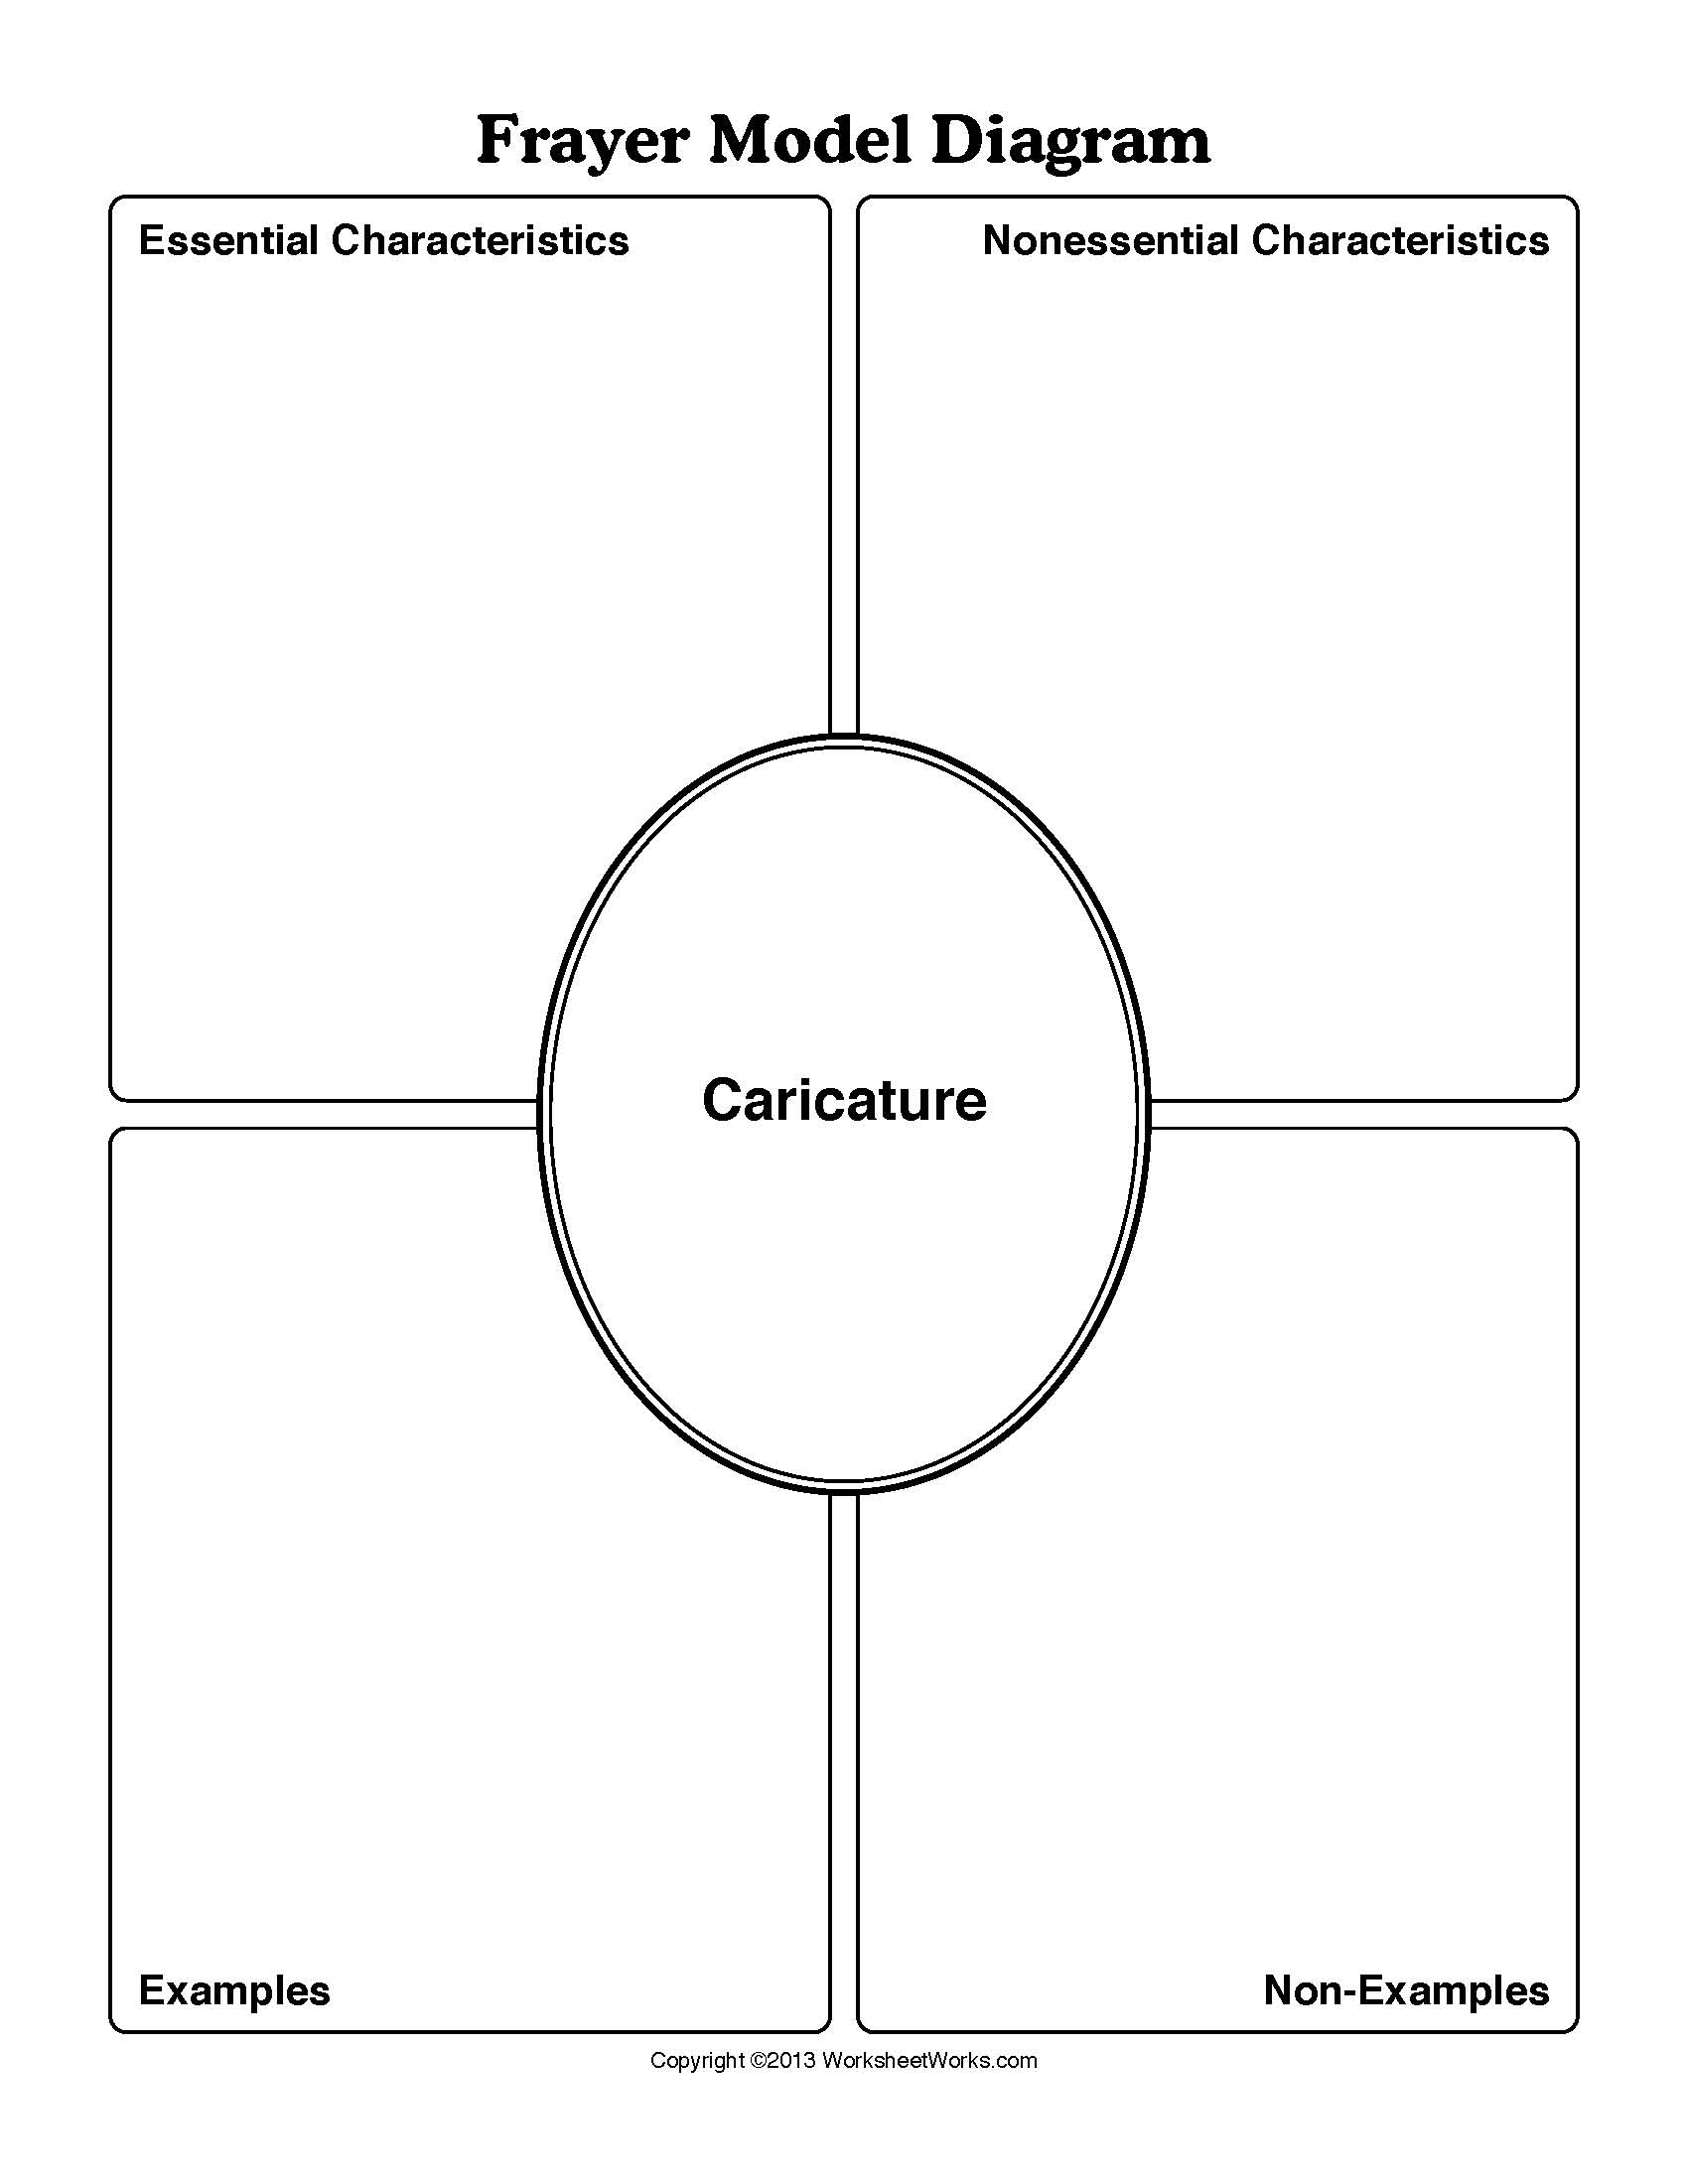
Peer Critique

Midway: discussion and problem solving

With your partner take turns looking at your artwork in progress. Analyze and discuss the following questions.

#1. Idea:
- Caricature helps us see ourselves with humour. What evidence do you see represented in your work of humour? Some things to consider: gesture, facial expression, background and symbols.

- Decision making and problem solving: What might you consider changing at this point in the process to make the work more humorous or interesting or innovative?

#2. Execution:
- This project allows you to consider both sculpting and painting technique. What evidence do you see of good technique? Some things to consider: brush technique, appropriate colour application with attention to detail, and use of medium.

- Decision making and problem solving: What might you consider changing at this point in the process to improve the work technically? What new media might be introduced?

Grade 9: Caricature Project
Use the outcome-based rubrics to create a rubric specific to the performance task. Invite students to examine the outcomes and identify key criteria that should be considered.

CP9.12 Solve visual art problems in new and unfamiliar ways.
- Take risks by working in unfamiliar ways (e.g. new ideas, techniques, or media)
- Experiment with new ways of using symbols and manipulation of images.
- Solve problems in innovative ways.
- Describe own decision making and problem solving processes and reflect on choices made.

Beginning - 1  I need help. | Approaching – 2  I have a basic understanding. | Meeting – 3  My work consistently meets expectations. | Excelling – 4  I have a deeper understanding
With assistance, I can experiment with new ways using symbols or manipulating images in visual art processes. | I can experiment and try challenging new methods in visual art processes. | I can solve visual art problems in new and unfamiliar ways. | I can describe own decision making and problem solving processes and reflect on choices made.

- Specific co-constructed criteria for the product: evidence of technical skills.
- Process folio: select three items that best illustrate your choices, experimentation and risk taking.
- Teacher conference: discussion of problem solving and process.
- Peer Critique: language of visual art, feedback.

Comments:

CR9.3 Investigate and identify how arts expressions can challenge thinking about values, ideas and beliefs.
- Describe how the arts can transmit or question values, ideas and beliefs.
- Examine the intentions, development and interpretations of own arts expressions in relation to own experience, values and perspectives.
- Investigate and explain why some arts expressions were considered to be controversial at different times in history.

Beginning - 1  I need help. | Approaching – 2  I have a basic understanding. | Meeting – 3  My work consistently meets expectations. | Excelling – 4  I have a deeper understanding
With assistance, I can investigate how art works are expressions of viewpoints and beliefs. | I can investigate how art works are expressions of viewpoints and perspectives and express beliefs. | I can investigate and identify how arts expressions can challenge thinking about values, ideas, and beliefs. | I can demonstrate interest in the ideas and works of artists and appreciate original thought and explain why some arts expressions may be considered controversial.

Checklist:
- Survey and journal reflection
- Frayer Model examples
- Journal & Visual library

Comments:

